CREATE TABLE studentnew(reg_no number(20),Student_name varchar(38),DOB date);

ALTER TABLE STUDENTNEW

ADD BloodGroup Varchar2(30);

ALTER TABLE STUDENTNEW ADD PRIMARY KEY(REG_NO);

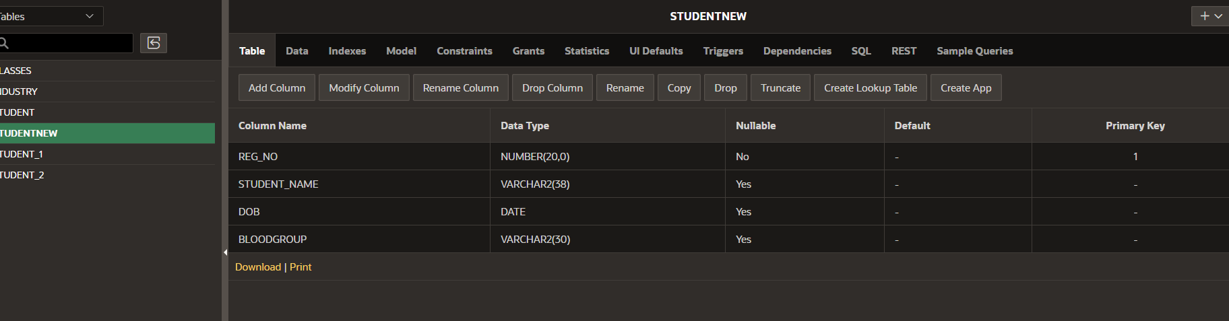

ALTER TABLE STUDENTNEW

ADD DEPARTMENT Varchar2(30);

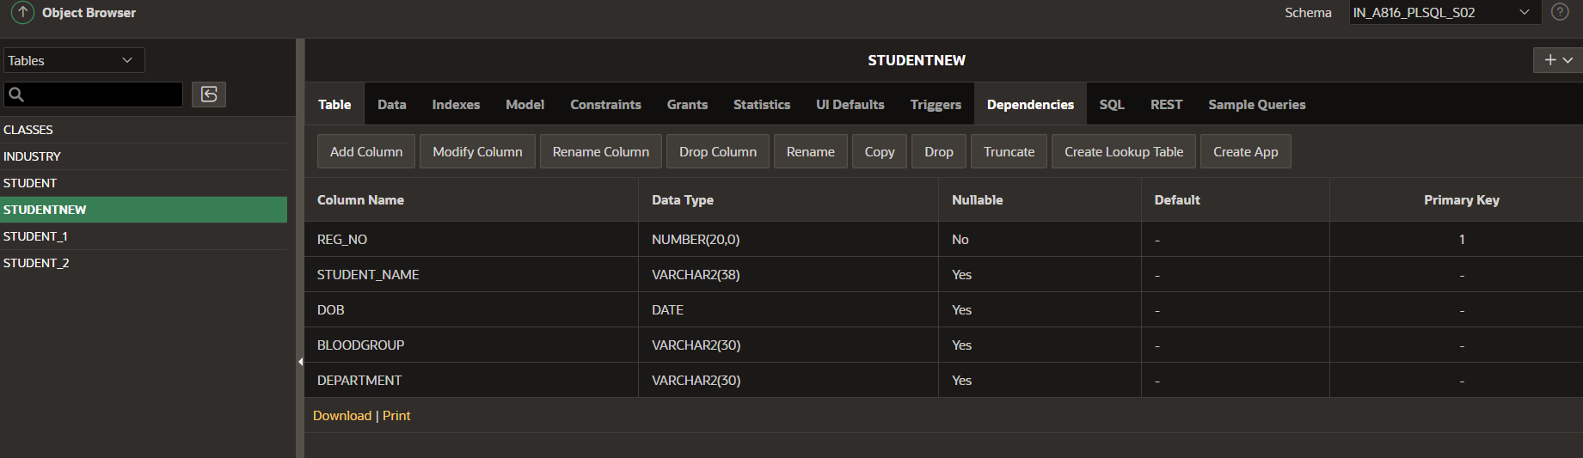

ALTER TABLE STUDENTNEW

DROP COLUMN DEPARTMENT;

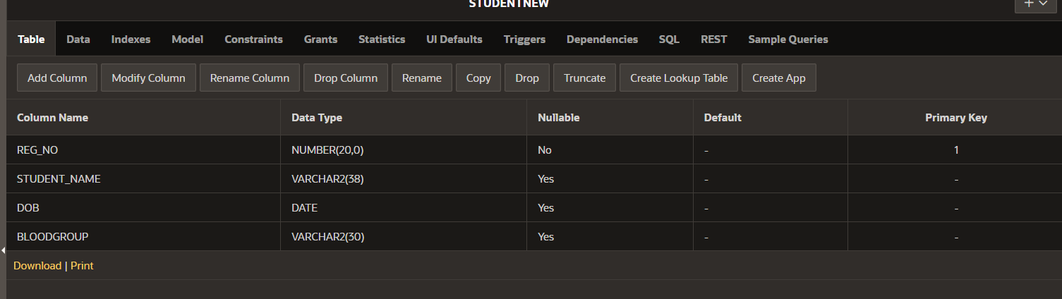

ALTER TABLE STUDENTNEW

RENAME COLUMN BloodGroup TO MARKS;

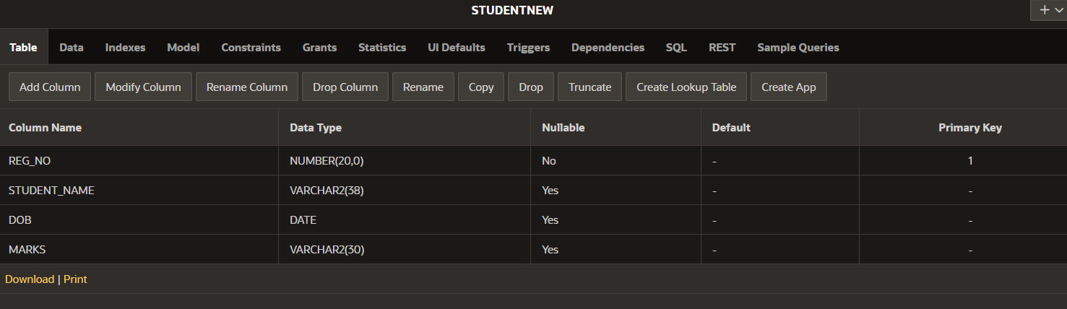

ALTER TABLE STUDENTNEW

MODIFY STUDENT_NAME Varchar(38) not NULL;

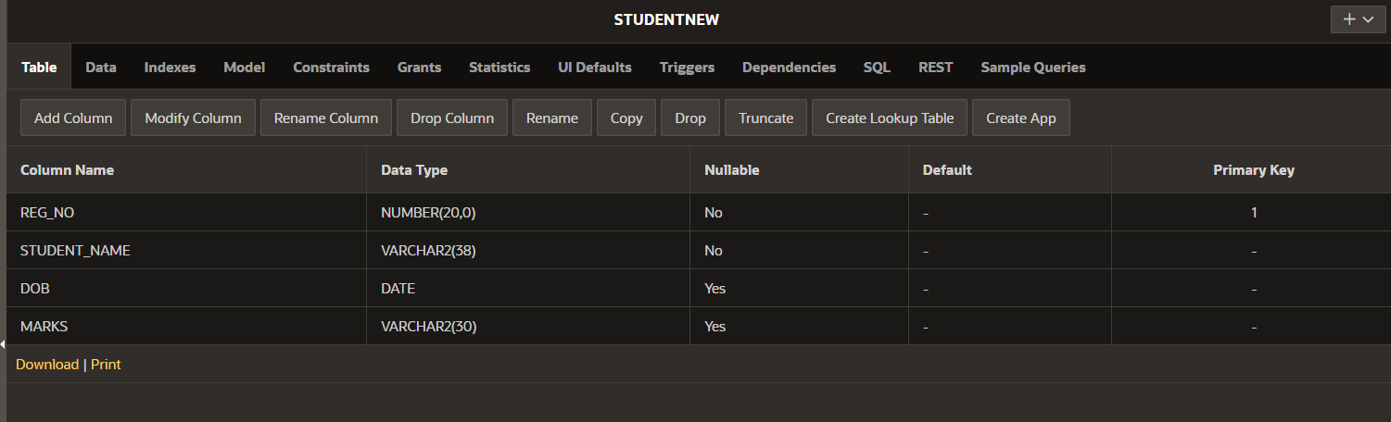

ALTER TABLE STUDENTNEW

MODIFY DOB Numeric Not NULL;

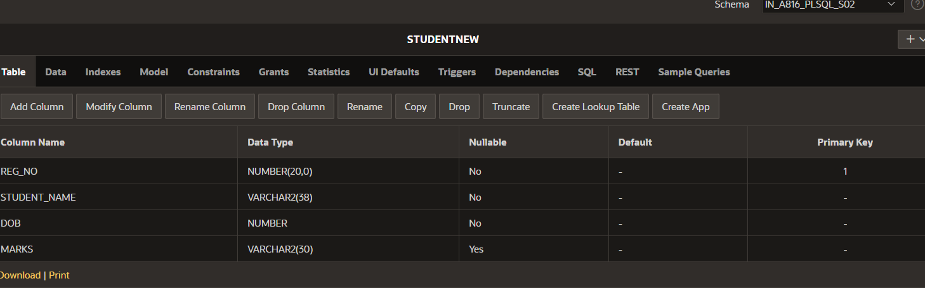

INSERT INTO STUDENTNEW VALUES(192311118,'PRIYA',2006,100);

INSERT INTO STUDENTNEW VALUES(192373016,'CHARVI',2005,105);

INSERT INTO STUDENTNEW VALUES(192311169,'HARIKA',2004,102); 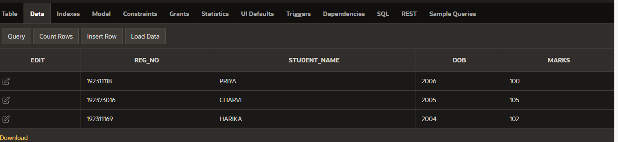

DELETE FROM STUDENTNEW

WHERE MARKS = 100; 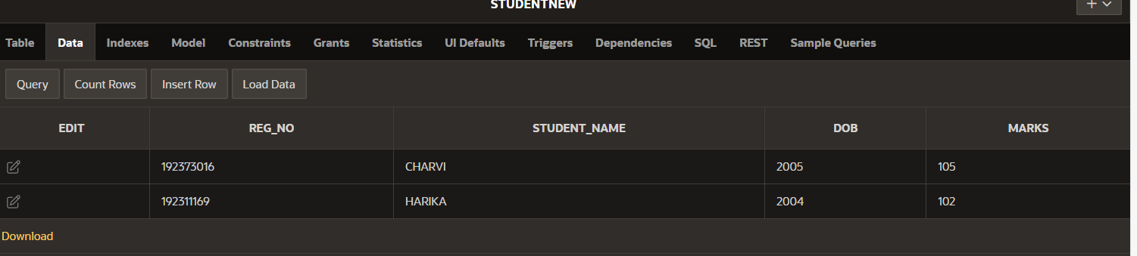

DELETE FROM STUDENTNEW;

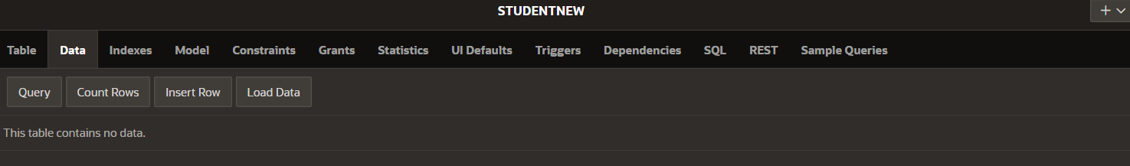

DROP TABLE STUDENTNEW;(FOR DELETING THE FIRST CREATED TABLE)0

CREATE TABLE STUDENTNEW(REG_NO number(20),STUDENT_NAME varchar(38),DOB DATE,BLOODGROUP varchar(20),DEPARTMENT varchar(15)); 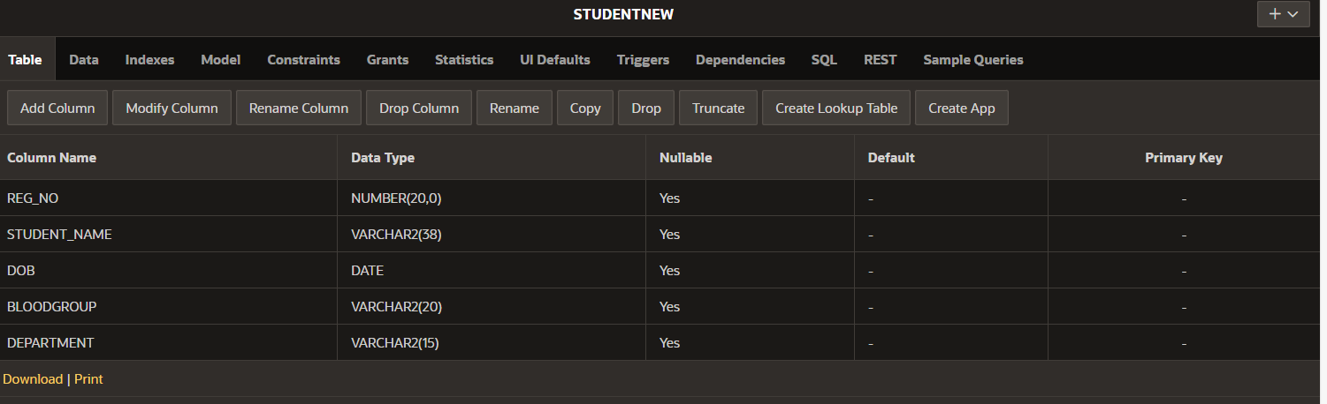

INSERT INTO STUDENTNEW VALUES(192311118,'PRIYADARSHINI',2006,'OPOSITIVE','CSE');

INSERT INTO STUDENTNEW VALUES(192373016,'CHARU',2010,'APOSITIVE','MEDICAL');

INSERT INTO STUDENTNEW VALUES(192311169,'HARIKA',2005,'BPOSITIVE','BIOTECH');

INSERT INTO STUDENTNEW VALUES(192376018,'KAVYANJALI',2024,'ABPOSITIVE','AIML');

INSERT INTO STUDENTNEW VALUES(192324133,'YASHASWINI',2007,'ABNEGATIVE','AIDS'); 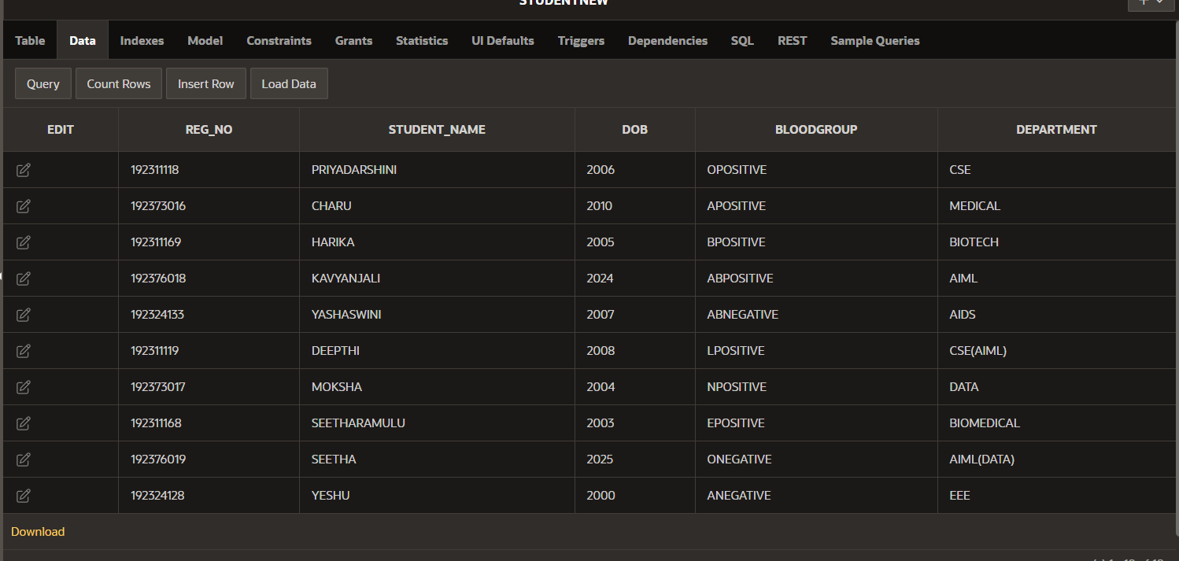

ALTER TABLE STUDENTNEW ADD PRIMARY KEY(REG_NO); 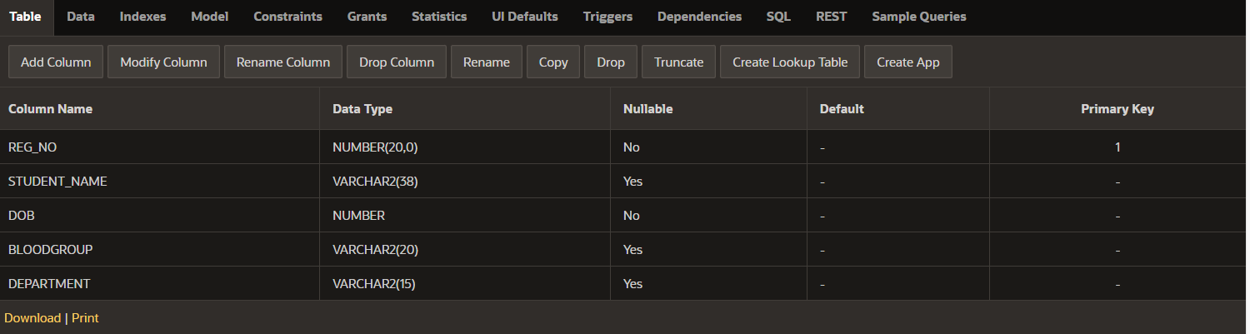

SELECT *

FROM STUDENTNEW;

SELECT STUDENT_NAME || DOB

FROM STUDENTNEW;

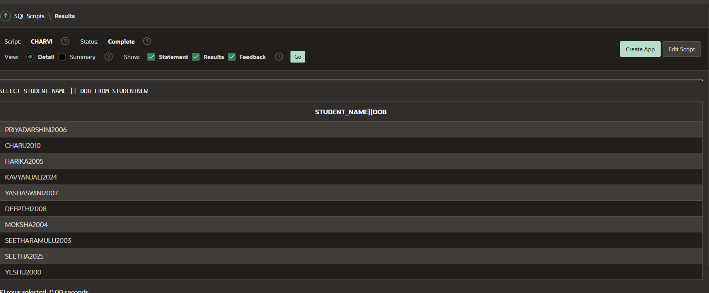

SELECT STUDENT_NAME,REG_NO

FROM STUDENTNEW

ORDER BY DOB;

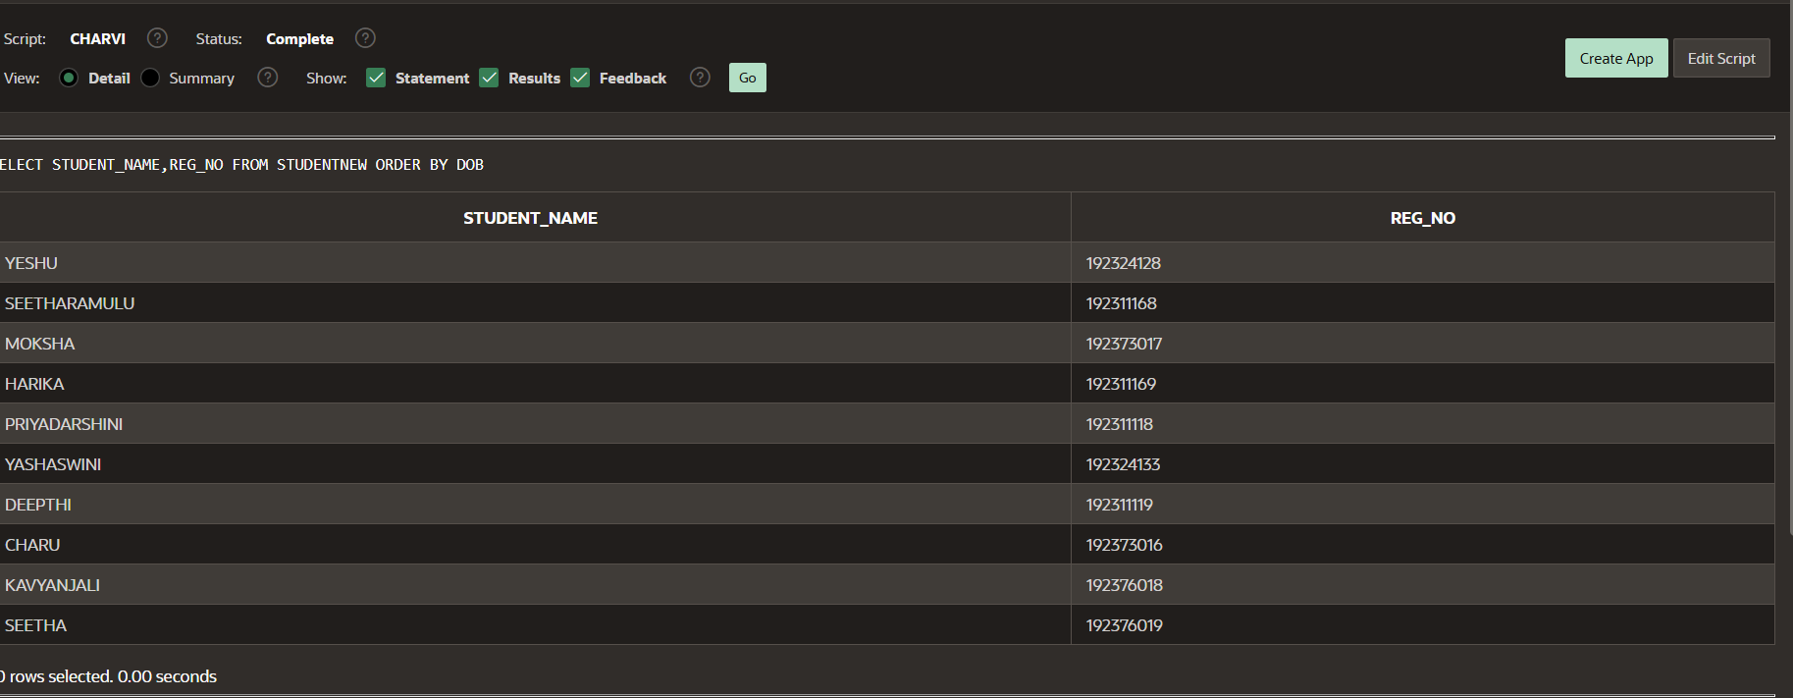

SELECT STUDENT_NAME

FROM STUDENTNEW

WHERE STUDENT_NAME LIKE '%_a%';

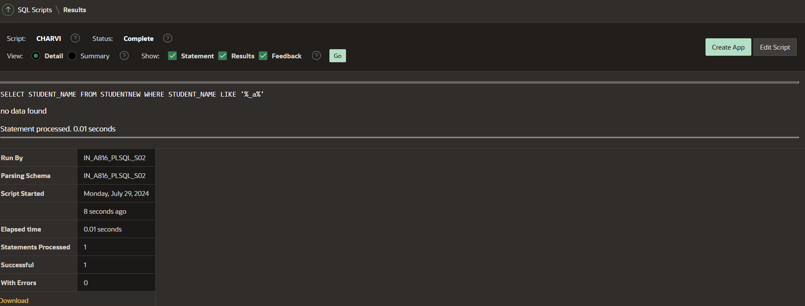

SELECT STUDENT_NAME

FROM STUDENTNEW

WHERE STUDENT_NAME LIKE '%_A%';

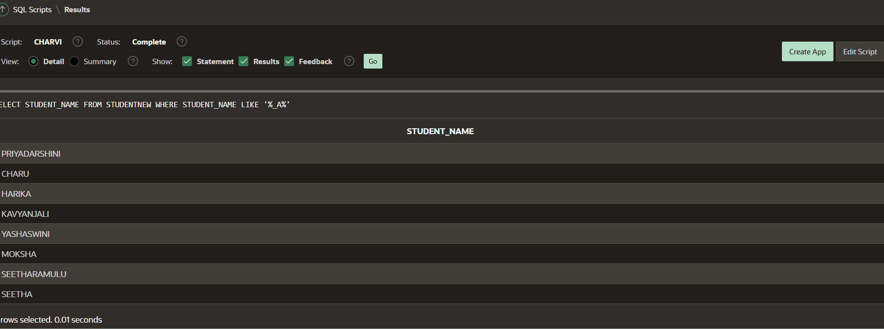

SELECT STUDENT_NAME

FROM STUDENTNEW

WHERE DEPARTMENT NOT IN('BIOTECH','EEE');

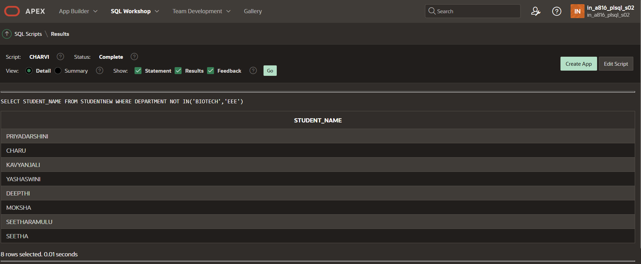

SELECT STUDENT_NAME,REG_NO,DOB

FROM STUDENTNEW

WHERE REG_NO>192311118 OR DOB<2006;

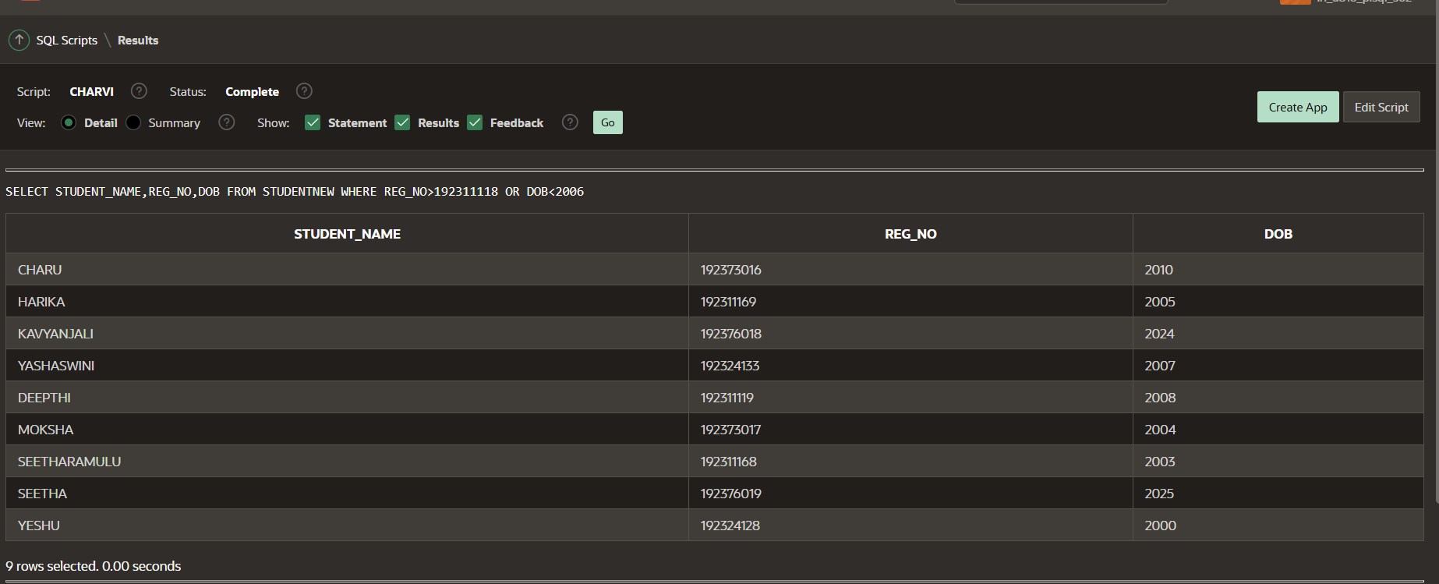

CREATE TABLE PERSON(PERSON_ID number(20),PERSON_NAME VARCHAR(20),DOB Date,BLOODGROUP varchar(35));

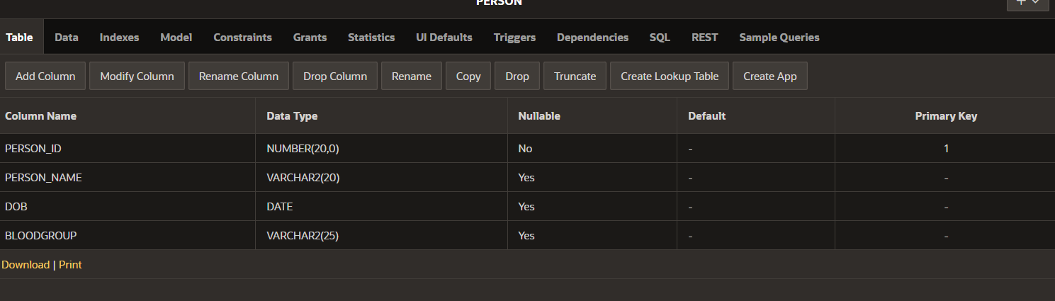

ALTER TABLE PERSON

ADD PRIMARY KEY(PERSON_ID); 

CREATE TABLE ORDERS(ORDER_ID number(20),PERSON_ID number(20),PERSON_NAME varchar(30),NUMBER_OF_ORDERS number(35)); 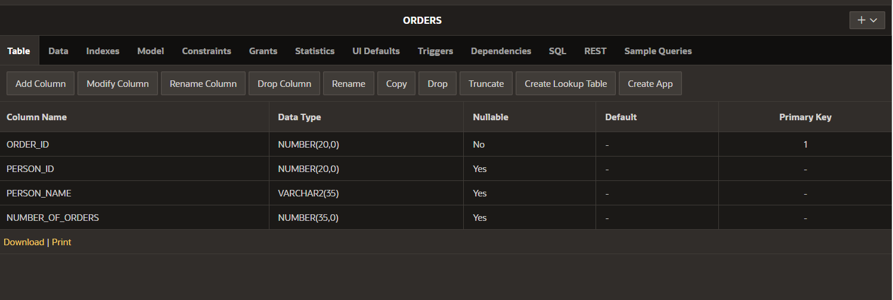

ALTER TABLE ORDERS

ADD PRIMARY KEY(ORDER_ID);



Alter table Orders add foreign key (Person_id) references Person(Person_id);

